Session 23:

More Kafka

Assignment 1

Task 1:

Create a java program MyKafkaProducer.java that takes a file name and delimiter as input arguments.

It should read the content of file line by line.

Fields in the file are in following order

1. Kafka Topic Name

2. Key

3. value

For every line, insert the key and value to the repsective Kafka broker in a fire and forget mode.

After record is sent, it should print appropriate message on screen.

Pass dataset_producer.txt as the input file and -as delimiter.

LINK: <https://drive.google.com/file/d/0B_Qjau8wv1KoSnR5eHpKOF9rTFU/view?usp=sharing>

Solution:

*Imports required for the program is given below:*

import org.apache.kafka.clients.producer.KafkaProducer; import org.apache.kafka.clients.producer.ProducerRecord; import java.io.BufferedReader;

import java.io.FileReader; import java.io.IOException; import java.util.Properties

*We configure the properties for KafkaProducer:*

o *We create a new instance of Properties called props*

o *Using this instance we add properties to kafkaProducer like,*

*bootstrapserver/meta-data-brokerlist, key and value serializers*

Properties props = new Properties(); props.put("bootstrap.servers", "localhost:9092"); props.put("key.serializer",

"org.apache.kafka.common.serialization.StringSerializer");

props.put("value.serializer", "org.apache.kafka.common.serialization.StringSerializer");

*We then instantiate the KafkaProducer class called producer, we have mentioned string in <> because both key and value are String*

*We add the properties instance (props)to KafkaProducer instance*

*We also instantiate ProducerRecord as producerRecord*

KafkaProducer<String, String> producer = new

KafkaProducer<>(props);

ProducerRecord<String, String> producerRecord = null;

In the terminal we run the following commands:

##Zookeeper Start Command $KAFKA_HOME/bin/zookeeper-server-start.sh \ $KAFKA_HOME/config/zookeeper.properties

## Starting broker $KAFKA_HOME/bin/kafka-server-start.sh \ $KAFKA_HOME/config/server.properties

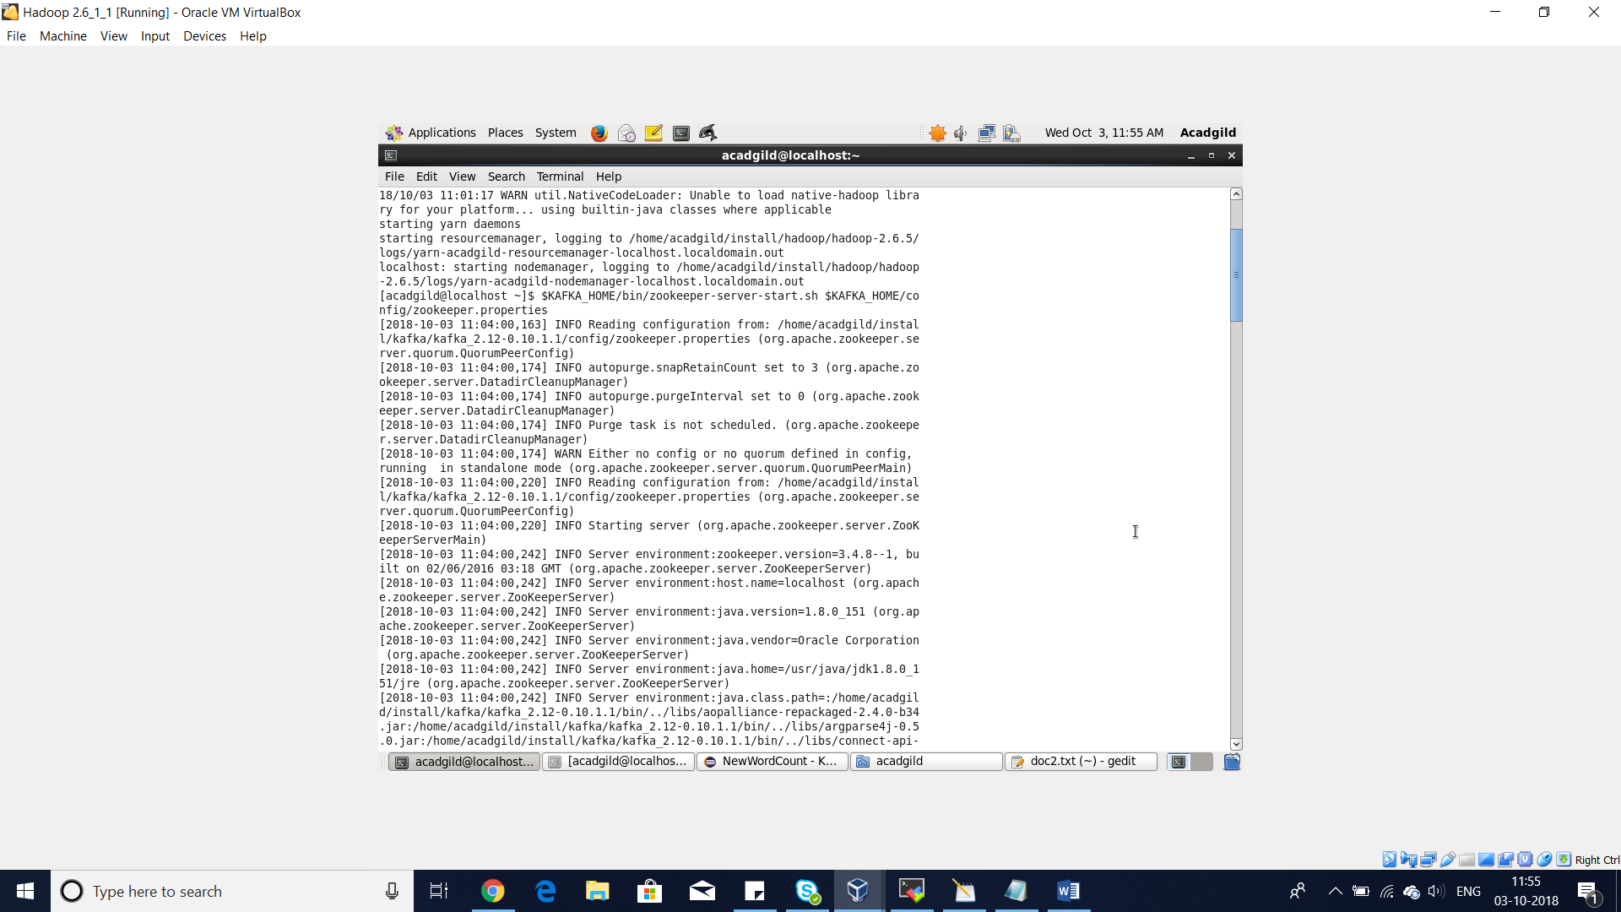

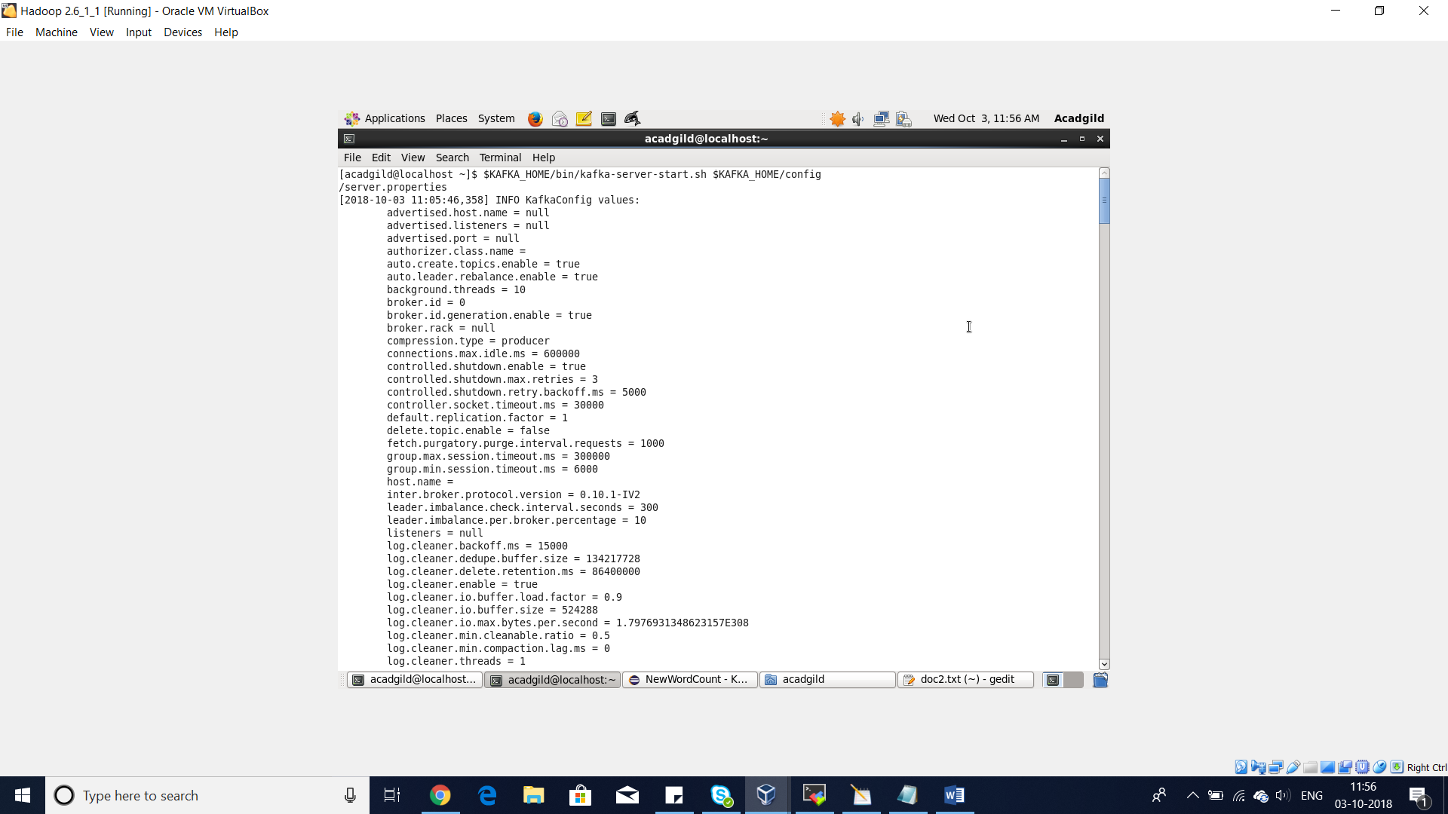

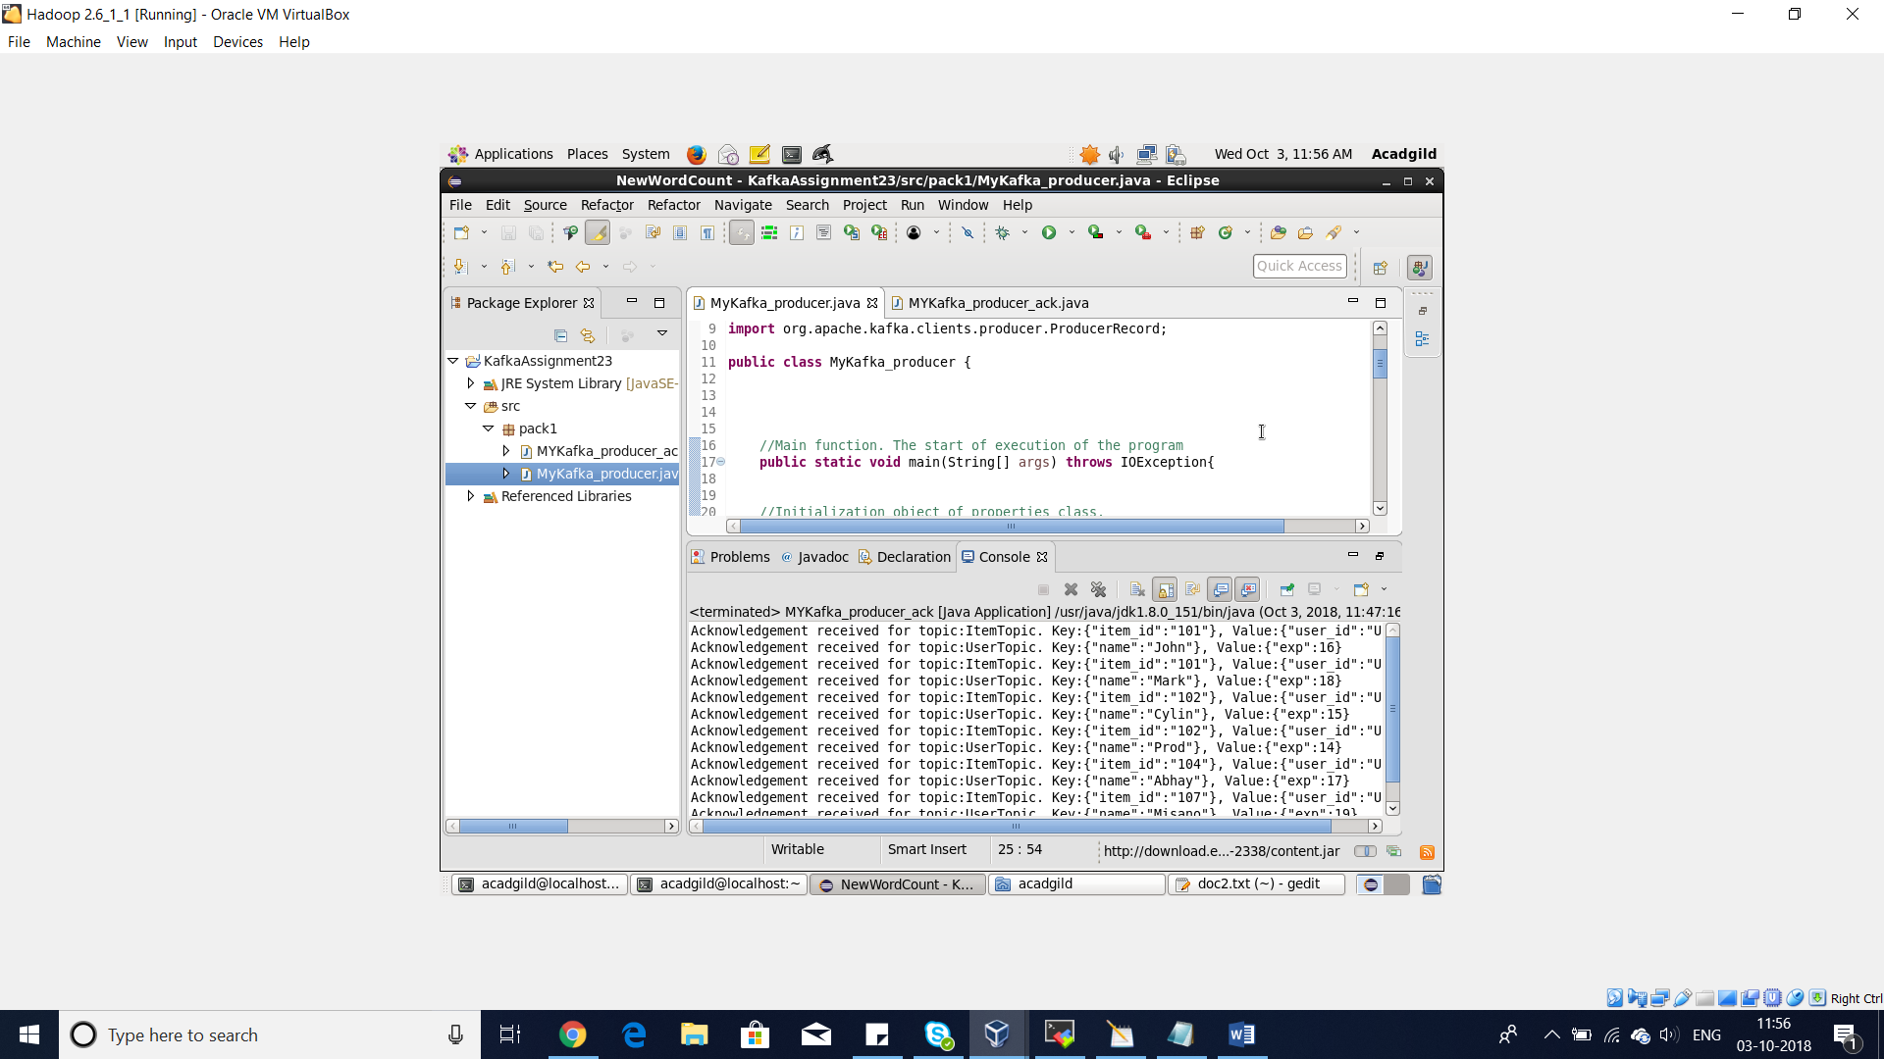

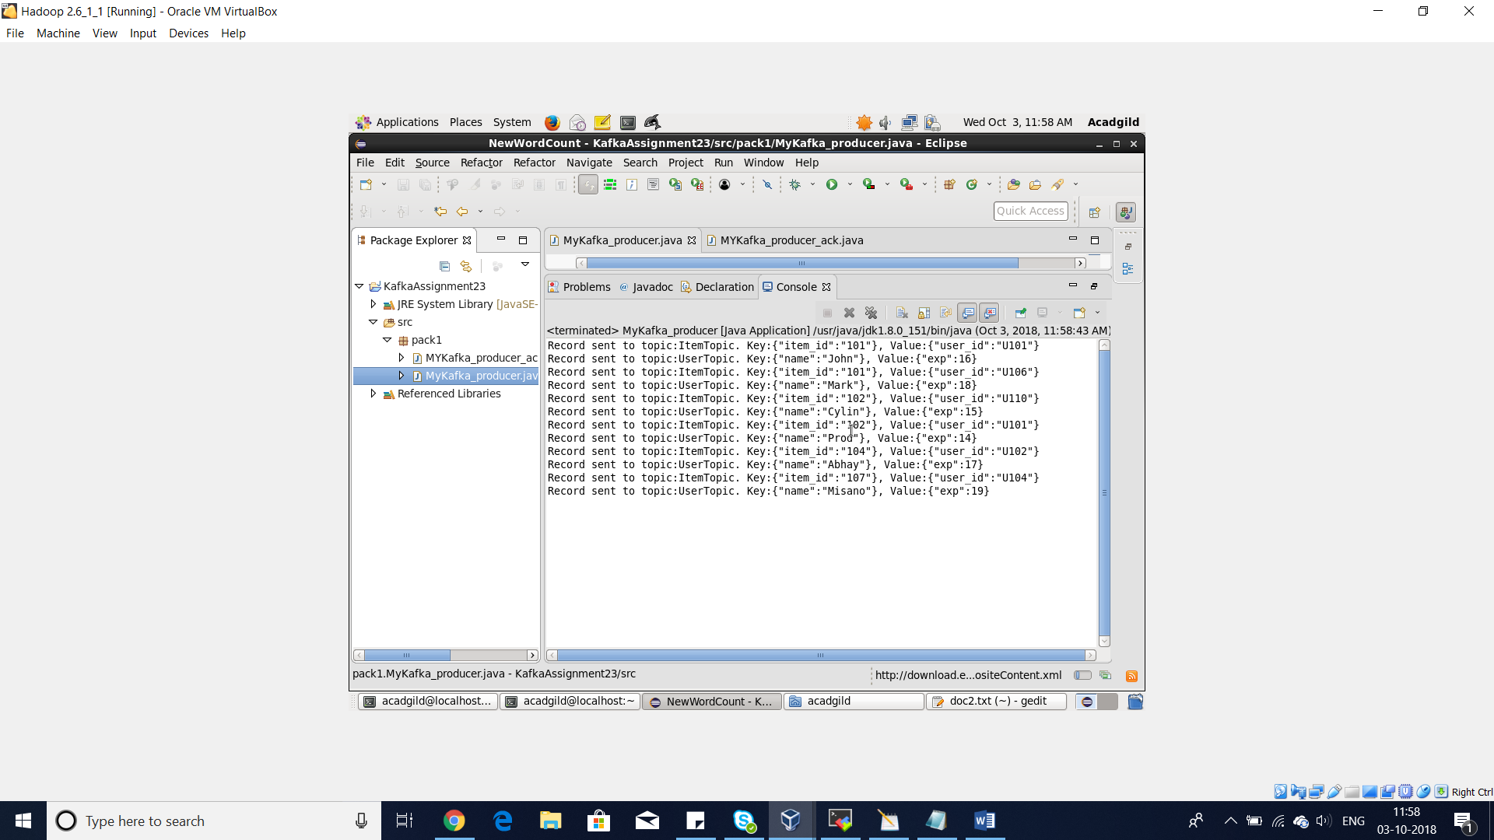

we run the console consumer commands on terminal to view the output of the program, using the below command:

o To read contents of ItemTopic:

*$ $KAFKA_HOME/bin/kafka-console-consumer.sh --topic ItemTopic --from-*

*beginning --zookeeper localhost:2181 --property print.key=true*

o To read contents of UserTopic:

*$ $KAFKA_HOME./bin/kafka-console-consumer.sh --topic UserTopic --from-*

*beginning --zookeeper localhost:2181 --property print.key=true*

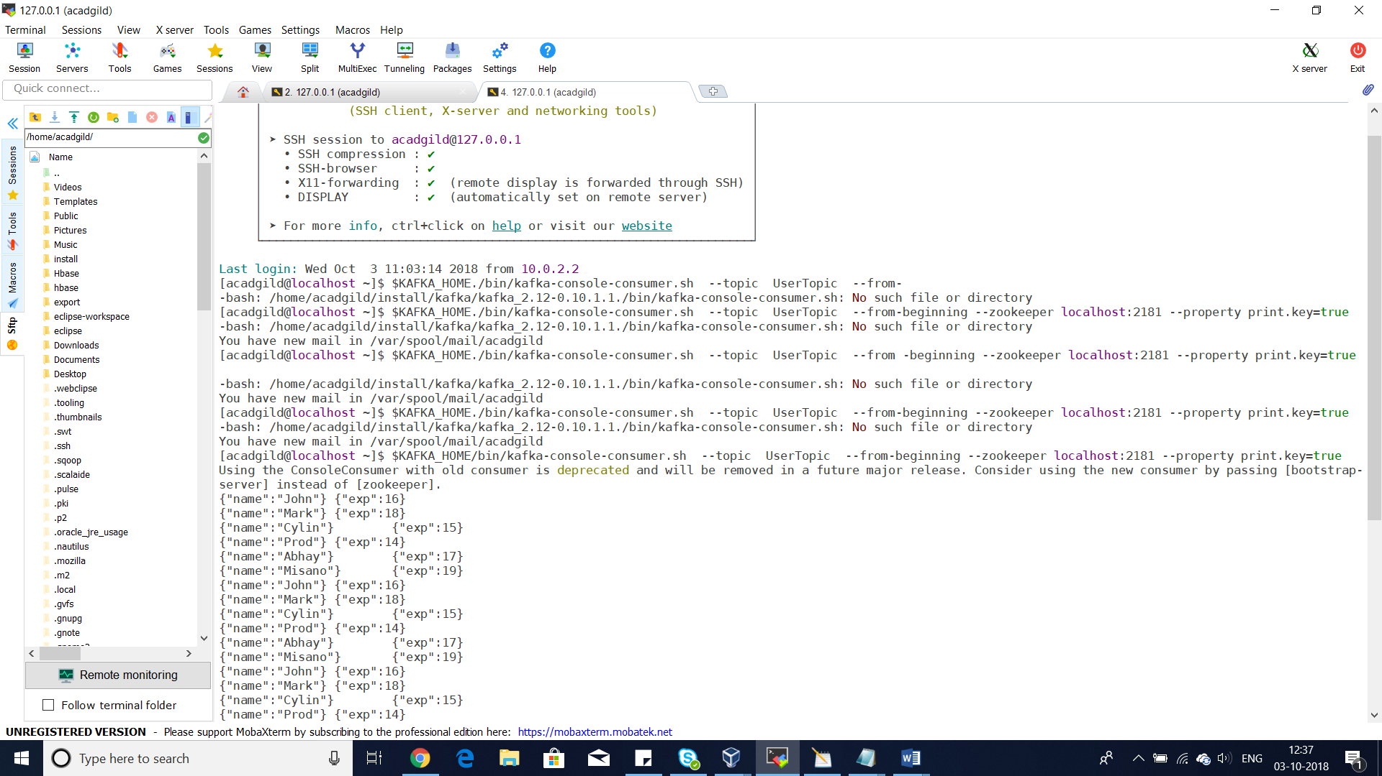

*$ $KAFKA_HOME/bin/kafka-console-consumer.sh --topic ItemTopic --from-*

*beginning --zookeeper localhost:2181 --property print.key=true*

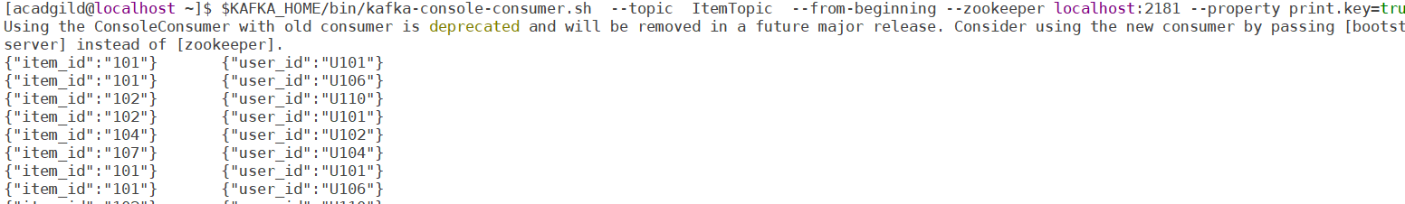

Task 2:

Modify the previous program MyKafkaProducer.java and create a new Java program

KafkaProducerWithAck.java

This should perform the same task as of KafkaProducer.java with some modification.

When passing any data to a topic, it should wait for acknowledgement.

After acknowledgement is received from the broker, it should print the key and value which has been

written to a specified topic.

The application should attempt for 3 retries before giving any exception.

Pass dataset_producer.txt as the input file and -as delimiter.

Solution:

